Differentiation Name: _________________________

Differentiate:
- 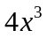

- 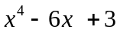

- 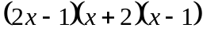

- 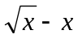

- 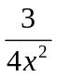

- 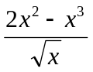

Differentiate:
- 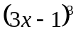

- 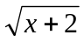

- 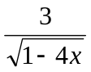

 | If 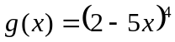, find 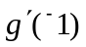.
 | If 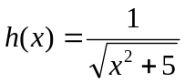, find 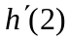.
5 | Differentiate each of the following.  a 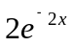  b 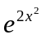  c 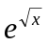
6 | Differentiate each of the following.  a 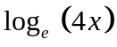  b 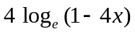  c 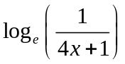
7 | Differentiate each of the following.  a 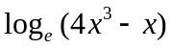  b 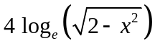
8 | Differentiate each of the following.  a 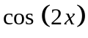  b 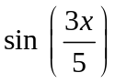  c 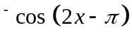
9 | Differentiate each of the following.  a 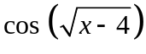  b 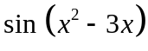  c 